HRA Members Save 10% at Nuffield Southampton Theatres this autumn season
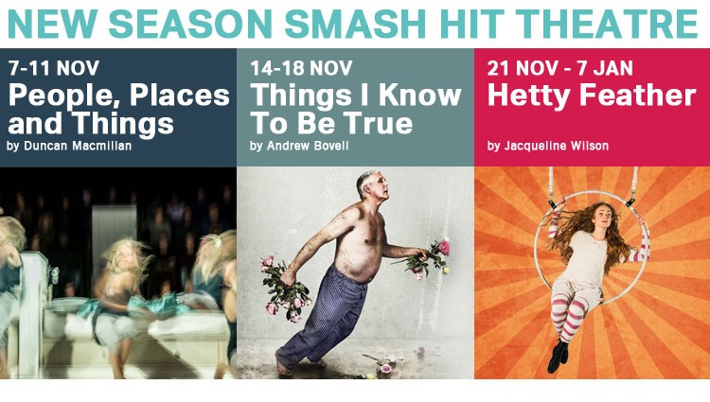

Book now and enjoy a season of smash hit theatre at NST
HRA Members’ Discount: 10% * Terms and Conditions Apply
Use Code: HIGHFIELDRA
Nuffield Southampton Theatres are offering exclusive discount to HRA members for the following shows this autumn season:
The Caretaker
A Bristol Old Vic and Royal & Derngate, Northampton co-production
By Harold Pinter
Directed by Christopher Haydon
Dates: 10-14 October 2017
Tickets: Starting from £10. Book early for the best prices.
A bold new adaptation of Pinter’s classic explores the search for a sense of belonging and identity, set against the paranoia of living in our politically and culturally uncertain times.
Book here: https://www.nstheatres.co.uk/campus/the-caretaker
People, Places & Things
A Headlong, National Theatre, HOME and Exeter Northcott co-production
By Duncan Macmillan
Directed by Jeremy Herrin
Dates: 7 -11 November 2017
Tickets: Starting from £10. Book early for the best prices.
Emma was having the time of her life. Now she is in rehab. When intoxication is the only way to survive, how can she ever sober up? Grim, disorientating, funny and dark, Headlong Theatre’s West End hit blurs the line between truth and reality.
Book here: https://www.nstheatres.co.uk/campus/people-places-and-things
Things I Know To Be True
A Frantic Assembly and State Theatre Company South Australia production
By Andrew Bovell
Co-directed by Scott Graham and Geordie Brookman
Dates: 14-18 November 2017
Tickets: Starting from £10. Book early for the best prices.
A beautifully touching story of a family facing shattering home truths. Blending Frantic Assembly’s potent physicality and formidable storytelling.
Book here: https://www.nstheatres.co.uk/campus/things-i-know-to-be-true
Hetty Feather
Nuffield Southampton Theatres in association with Kenny Wax, William Archer and Novel Theatre present a Rose Theatre Kingston production
By Jacqueline Wilson
Adapted for the stage by Emma Reeves
Directed by Sally Cookson
Dates: 21 November 2017 – 7 January 2018
Tickets: Starting from £10. Book early for the best prices.
Join tomboy Hetty Feather on an audacious adventure in this Olivier nominated West End hit, featuring daring circus skills, original songs and live music.
Book here: https://www.nstheatres.co.uk/campus/hetty-feather

Tickets are available from the Box Office 023 8067 1771 or online at nstheatres.co.uk
*Terms & conditions apply: Receive 10% off full-price band B & C tickets for The Caretaker, People, Places and Things, Things I Know To Be True and Hetty Feather at Nuffield Southampton Theatres Campus using offer code HIGHFIELDRA. For full terms and conditions, please see https://www.nstheatres.co.uk/terms-conditions.

