**Portswood Library Newsletter Aug 2019**

Friday 9th Aug 11-12 noon **Postcards to Aliens**

Tuesday 13th Aug 10:30 – 12:30 **Astro Art** **ro Art**

**Regular activities for adults**

**Knitwits Knitting group Monday 5 – 6:30**

**Family Tree your ancestors, your history Mon 5 – 6:30**

**A drop in session to get basic hints and tips in researching your family tree**

**Friends of Portswood Library**

**Find them on Facebook! [](https://www.google.co.uk/url?sa=i&rct=j&q=&esrc=s&source=images&cd=&ved=2ahUKEwivm-zmocjiAhUL3BoKHbfLCgkQjRx6BAgBEAU&url=https://en.wikipedia.org/wiki/Facebook&psig=AOvVaw2_5zkBoj_chWjBwp42BFMI&ust=1559477827675888)**

All activities are suitable for children 4+

No need to book but carers need to stay with their children

*For activities in other libraries, please visit thelibrarywebsite* [*www.southampton*](http://www.southampton)*. gov.uk/libraries*

***Bank Holiday Monday 26th Aug Library closed***

**Opening Hours**

Mon 10 – 7 Tues 10 – 5 Weds 10 – 7 Thurs – closed Fri 10 – 5 Sat 10 – 4 **the computers switch off 15 minutes before the library closes**

[](https://www.google.co.uk/url?sa=i&rct=j&q=&esrc=s&source=images&cd=&ved=2ahUKEwjKr5bZzN_jAhXh8OAKHcnBChAQjRx6BAgBEAU&url=https://www.vectorstock.com/royalty-free-vector/colorful-cartoon-birthday-cake-5-candles-vector-21114380&psig=AOvVaw3ZnXmfZYw-DNORawmwShbw&ust=1564677657587863)

**Friends of Portswood Library 5th Anniversary Celebrations Sat 10th Aug 10:30 – 12:30 Come and join us for free cake and a cold drink**

[](https://www.google.co.uk/url?sa=i&rct=j&q=&esrc=s&source=images&cd=&ved=2ahUKEwjxw8TgvcjiAhVMJBoKHQgsBwEQjRx6BAgBEAU&url=https://www.southampton.gov.uk/libraries/library-activities/summer-reading-volunteers.aspx&psig=AOvVaw0wz0LZ0KOWD8oXYv1OQ2m2&ust=1559485048032522)

Read six books over the summer holidays to get rewards, a certificate and a gold medal

Finishes 31st August Come and join the fun!

[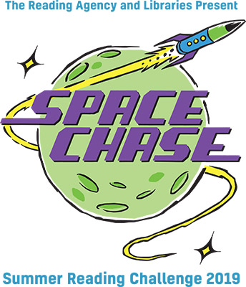](https://www.google.co.uk/url?sa=i&rct=j&q=&esrc=s&source=images&cd=&ved=2ahUKEwi0h9GNqM3iAhUHbBoKHVx-CSQQjRx6BAgBEAU&url=https://readingagency.org.uk/children/quick-guides/summer-reading-challenge/&psig=AOvVaw1Axp4n-zW2YyFUrXnr8Xnd&ust=1559651322686484)

[](https://www.google.co.uk/url?sa=i&rct=j&q=&esrc=s&source=images&cd=&ved=2ahUKEwjepuC_yt_jAhWFxIUKHZksCTkQjRx6BAgBEAU&url=https://www.worldatlas.com/articles/what-does-the-italian-flag-look-like.html&psig=AOvVaw05jNwK-y27w9ljoPxA4SkF&ust=1564677075041724)

**Weds 14th Aug 7:30**

**Friends of Portswood Library evening talk Portswood Manor and the Italian Connection Ally Hayes and Wendy Stokes**

Holiday activities for children

**Wed 7th Aug** 10:30 – 12:00 Pocket Solar System

**Wed 14th Aug** 10:30 – 12:00 Design your own Planet

**Wed 21st Aug** 10:30 – 12:00 Alien Space Craft

