**Portswood Library Newsletter Oct 2019**

**Opening Hours**

Mon 10 – 7 Tues 10 – 5 Weds 10 – 7 Thurs – closed Fri 10 – 5 Sat 10 – 4 **The computers switch off 15 minutes before the library closes**

**Sat Oct 5th**

**10:30– 1:00**

[](https://www.google.co.uk/url?sa=i&rct=j&q=&esrc=s&source=images&cd=&cad=rja&uact=8&ved=2ahUKEwiZ4uf1qPjkAhWKlRQKHXYpBQoQjRx6BAgBEAQ&url=https%3A%2F%2Fwww.justgiving.com%2Ffundraising%2Fcoffeetwibbon&psig=AOvVaw0D0EIBzVEIyqxadBFDO6Fg&ust=1569925037136751) **Friends of Portswood Library invite you to a**

**MacMillan Coffee Morning**

Weds 30th October

Half Term Activity

*Seasonal Paper Chains*

[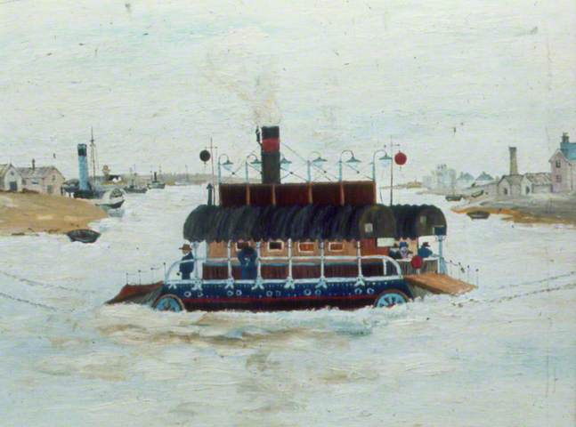](http://www.google.co.uk/url?sa=i&rct=j&q=&esrc=s&source=images&cd=&ved=2ahUKEwjAidLrovjkAhXi8OAKHRjCAnIQjRx6BAgBEAQ&url=http%3A%2F%2Fsotonopedia.wikidot.com%2Fpage-browse%3Ameadus-eric&psig=AOvVaw1faYD3IiWJ7RfyL0dLIj_Q&ust=1569923458074279)

[](https://www.google.co.uk/url?sa=i&rct=j&q=&esrc=s&source=images&cd=&ved=2ahUKEwjzytWt1bfkAhWHDGMBHU1sBv8QjRx6BAgBEAQ&url=https://www.pinclipart.com/pindetail/xxhRo_advertisement-clipart-computer-worker-person-at-desk-icon/&psig=AOvVaw0rGNRvLS2sNM50RgvN9fiq&ust=1567703584162120)

*Do you need help using a computer?*

Our Digital Champion, Roy, is holding a drop in session on Mon 7th Oct 10:15 – 11:45

*Thursday 17th Oct*

*Computer Club, run by the Red Cross*

Let’s Make a Poem! Poetry workshop with Isobel Armstrong Friday Oct 25th 2 – 3:30 Share your voice and discover the joy of words

[](https://www.google.co.uk/url?sa=i&rct=j&q=&esrc=s&source=images&cd=&ved=2ahUKEwi0h9GNqM3iAhUHbBoKHVx-CSQQjRx6BAgBEAU&url=https://readingagency.org.uk/children/quick-guides/summer-reading-challenge/&psig=AOvVaw1Axp4n-zW2YyFUrXnr8Xnd&ust=1559651322686484)

**Friends of Portswood Library**

**Find them on Facebook! [](https://www.google.co.uk/url?sa=i&rct=j&q=&esrc=s&source=images&cd=&ved=2ahUKEwivm-zmocjiAhUL3BoKHbfLCgkQjRx6BAgBEAU&url=https://en.wikipedia.org/wiki/Facebook&psig=AOvVaw2_5zkBoj_chWjBwp42BFMI&ust=1559477827675888)**

Regular activities for Children

**Tuneful Tots** Alternate Tues 11 o’clock

**Tues 1st 15th 29th Oct**



**Storytime and Craft**

Wednesdays 11 – 11:30am Term time only

Wednesday 16th Oct 7:30pm

**Friends of Portswood Library evening talk Ally Hayes and Wendy Stokes Painting the Town**

**Regular activities for adults**

**Knitwits Knitting group Monday 5 – 6:30**

**Family Tree your ancestors, your history Mon 5 – 6:30**

**A drop in session to get basic hints and tips in researching your family tree**

