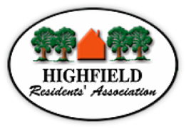
Agenda HRA Committee Meeting
Held on 12 April 2021
Via Zoom 19:00h

Prof. Roger Brown will Chair the meeting

- Prof. Roger Brown - Welcome and opening remarks
- Declarations of interest -
- Apologies –
- Minutes from March 2021 have been circulated

- Matters Arising – Zoom with Jon Willetts 21 April regarding Conservation Areas; e-Scooters update

- Information from Councillors –
  - Transforming Cities Portswood and Swaythling

- Membership casework:
- Rented properties and rubbish in gardens – Omdurman Road
- Fly-tipping – Highfield Lane area

- University Liaison –
- Reports
  - Finance (MB)
  - Membership (BC for NM)
- Planning Report (AS)
- Updates on planning casework: 7, Brookvale Road (BC)

- Police liaison – 'Crime information sharing WhatsApp group' (for Highfield) (NJ)

- Website / Facebook (NJ)

- City of Culture (KB)

- The Little Common: update on future plans (SO)

- A.O.B.
  - Waste of Space appeal (NJ)
http://www.highfieldresidents.org.uk/hampshire-and-isle-of-wight-wildlife-trusts-waste-of-space-appeal/

