4 Woodstock Drive
Highfield
Southampton
SO17 1WY
Tel. & Fax. +44 (0)2380 586236
Mobile 07966 173296
Email: woodstockhouse@btinternet.com
Mss Anna Lee
Development Management
Civic Centre
So’ton City Council
SO14 7LY Mon 22nd May 17

17/00709/FUL

Dear Mss Lee,

We wish to object to this application on the following grounds, but would first point out there is a long outstanding Enforcement to reinstate these garages to their proper use, as they are and have been for a long time, used illegally as bedroom/living accommodation.

I would also point out that where there is an outstanding Enforcement the Council are not obliged to consider any further/retro Planning applications and may summarily dismiss it, which, given the long and tortuous history over many years of this property, we ask should be done. I further attach a copy of a letter recently received from the Minister of Housing confirming this point; (see para 1 page 2)

In terms of providing conventional reasons for objection we can do no better than to refer to all of our previous correspondence over many years on this matter and also the three previous Appeal Decisions which I have already forwarded to you. However, in these particular circumstances it would be wise to perhaps emphasise some of the points raised in previous Inspectors Decisions, e.g.
- Precedent - in that it would be difficult for the Council to refuse similar application in the future, of which there have been several
- Parking – the loss of any garage space will only exacerbate this already difficult problem.
- Intensification of use – to allow additional bed spaces would be out of character with the rest of the development thus causing...
- Material harm – and further damage to the character and amenity of the area.

There is a particular concern with this property that any permission for an alternative use of the garage/s would result, as is now the case, in either continued use, or future conversion to additional bed spaces which would be difficult to monitor. In this case there is ample evidence to support this belief as indeed was supported by the Planning Inspector previously. This being the case it would clearly be unwise to allow any alternative use as might otherwise be considered and we ask therefore that this application now be refused without further debate and the outstanding Enforcement implemented without further delay.

I also attach details from one of the Directors of the Crofton Close Management Co. giving chronological details of past actions and relevant decisions taken.

Should you not decide to decline to determine this application as per the Localism Act 2011 or to summarily refuse it under your delegated authority we ask you would advise us accordingly before the expiry of the consultation period.

Many thanks,

yours sincerely,

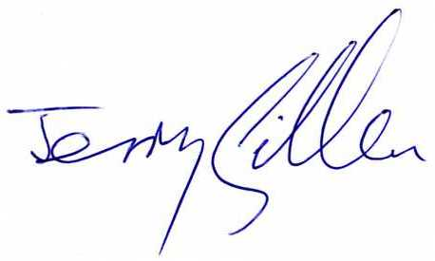
Jerry Gillen
Vice Chairman

