4 Woodstock Drive
Highfield
Southampton
SO17 1WY
Tel. & Fax. +44 (0)2380 586236
Mobile 07966 173296
Email: woodstockhouse@btinternet.com
Development Management
Southampton City Council
SO14 7LY Fri 10th Feb 17
17/00139/FUL
14 Crofton Close, SO17 1XB

Dear Planning Control,

We have been asked to object to this application on behalf of the immediate neighbour at No 13 Crofton Close and ask that the following reasons be taken into account for rejecting this application...

- The proposed extension will effectively double the size of the existing property and would therefore be an overdevelopment in terms of both massing and scale
- This would lead to an over intensification of use.
- It would have a dramatic effect on the adjacent property in terms of loss of light and over-shadowing to the rear garden.
- As a consequence this would breach the 45 degree rule for blocking of light.
- This would cause material harm to the adjacent property
- Similarly this would harm the character of Crofton Close and damage the amenity of the neighbours.
- Any increase in potential use would create addition problems with Parking.

For all the above reasons we ask this be refused under Delegated Powers, failing which it should be brought before the P&RW Panel.

Yours faithfully,
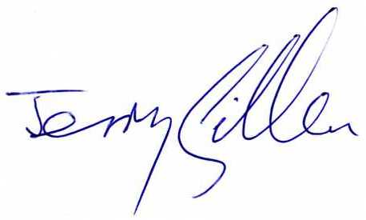

J Gillen
Vice Chairman

