UPDATE ON BLOCKBUSTER SITE

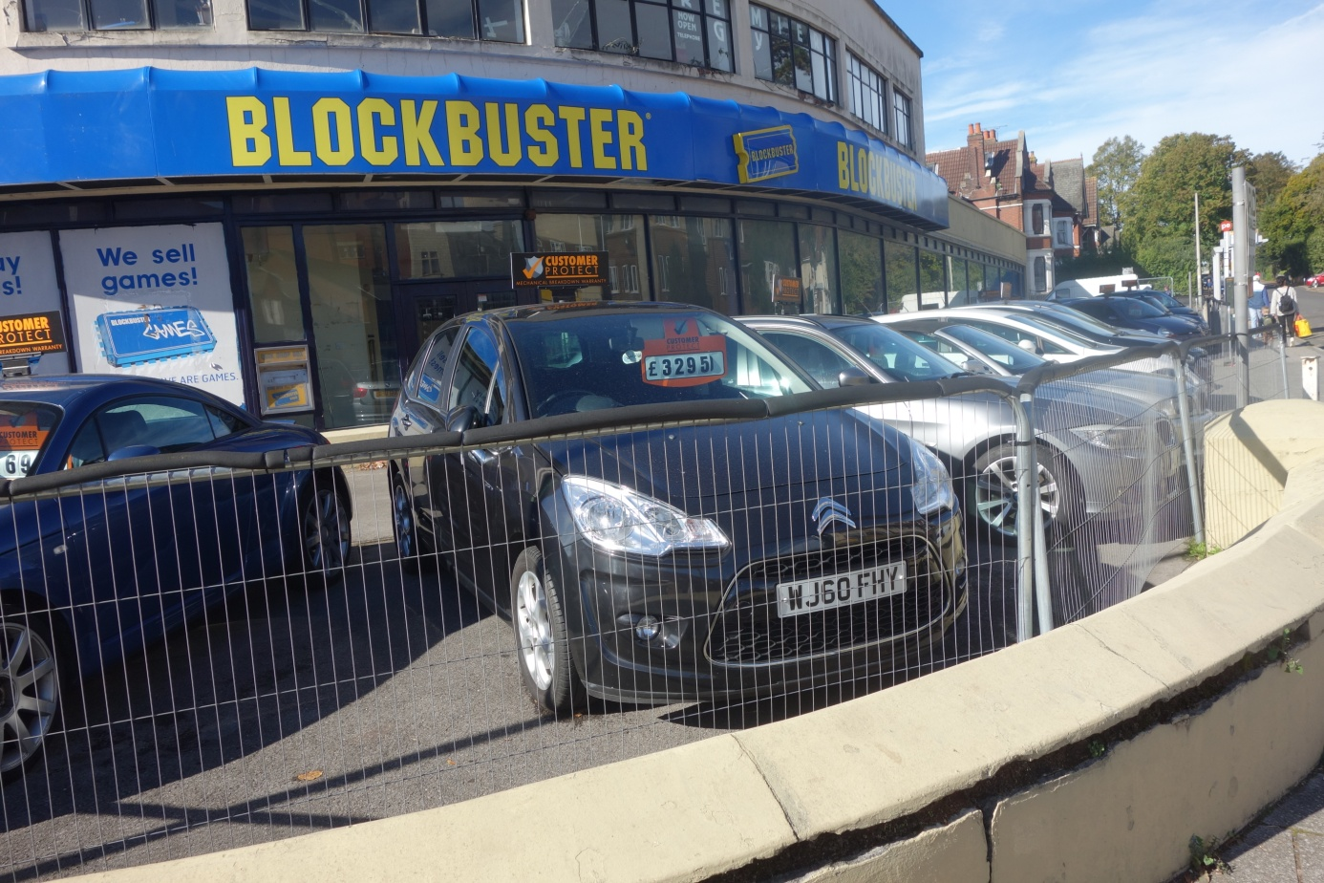

The planning department has received a request for retrospective permission for the above; however the Highways Planning Manager has put in a recommendation for refusal based on the unsuitability of the site for the amount of manoeuvring required at a busy junction.

The application has not yet been determined, but such a recommendation would not be ignored.

There is of course the complication in any case of the application for a development of student accommodation on the same site, which will be determined before early December.

So, even if the student accommodation application does not succeed, the car sales application will in all probability be resisted.

Jill Baston

Planning Rep

Highfield Residents’ Association