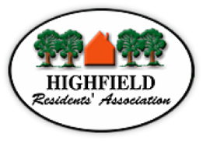
Agenda 43rd HRA Annual General Meeting
11 April 2019
At Highfield House Hotel 7.30pm

7.30pm | - Introduction and welcome from the the Sheriff, Cllr Peter Baillie
7.35pm | Professor Roger Brown will take the Chair:
 | - Apologies for absence
7.40pm | - Minutes of the previous AGM held on 19 April 2018 – circulated in advance and taken as read
7.45pm | - Acting Chair Jerry Gillen – Annual Report - followed by any questions
7.55pm | - Treasurer’s Report Adrian Ford – followed by any questions
8.05pm | - Election of Officers for the coming year:
 | Acting Chair | Jerry Gillen
 | Treasurer’s Assistant | Martin Benning
 | Secretary and Minuting Secretary | Barbara Claridge
8.15pm | - Re-election of existing Committee Members wishing to stand again:  Steven Johnston (Newsletter Editor), Mark Bachelor (Treasurer)
8.20pm | - Ratification of other committee members:  Ken Burtenshaw, James Burgess, David White, Martin Benning and Angela Seymour
8.25pm | Jerry Gillen will take the Chair to introduce the Speaker:
 | - Professor Roger Brown ‘The Future of Southampton Common’
8.40pm – 8.45pm | - A.O.B. Followed by close of the meeting

We hope that you will be able to stay for the informal social gathering with complimentary drinks,
sponsored by Highfield House Hotel which follows the meeting

