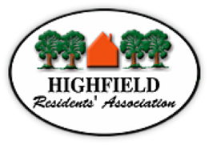
Agenda HRA Committee Meeting
Tuesday 12 October 2021
Highfield Church Hall Lounge Room 19:00h

Prof. Roger Brown will Chair the meeting

Part I – All attendees
- Prof. Roger Brown - Welcome and opening remarks:
- Declarations of interest
- Apologies
- Minutes from September 2021 (Zoom) have been circulated
- Matters Arising not covered elsewhere (Local Plan; The OTRA green trail)

- Information from Councillors
- University Liaison (JW / KF)
- Planning update – see the attached Planning Grid
  - HRA
  - Any others
- Reports
- Finance (MB) – income/expenditure for the last period
- Membership (NM)
- Newsletter (SO or BC)
- Police liaison – Crime information sharing WhatsApp group (for Highfield) (NJ)
Website / Facebook (NJ)
- A.O.B.
Part II – HRA Committee Members only
- A.G.M. Matters to discuss in outline: Please read all attachments in advance of the meeting and print your own copies if required
  - AGM Agenda (draft)
  - HRA Subscriptions after the AGM and recommendation (MB)
  - Amendments to the Constitution (Special General Meeting)
  - Approval of Accounts (2019, 2020), formal appointment of Examiner
  - Payment of subscriptions by Direct Bank Transfer – progress (BC)
  - Guest speaker
  - Jobs at the AGM

