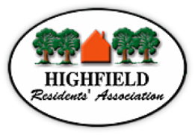
Agenda HRA Committee Meeting
Tuesday 2 November 2021
Highfield Church Hall Lounge Room 19:00h

Prof. Roger Brown will Chair the meeting

Part I – All attendees
- Prof. Roger Brown - Welcome and opening remarks:
- Declarations of interest
- Apologies
- Minutes from 12 October 2021 have been circulated
- Matters Arising not covered elsewhere
- Information from Councillors
- University Liaison (JW / KF)
- Planning update –
  - HRA
  - Any others
- Reports
- Finance (MB) – income/expenditure for the last period
- Membership (NM)
- Newsletter (SO or BC)
- Police liaison – Crime information sharing WhatsApp group (for Highfield) (NJ)
Website / Facebook (NJ)
- A.O.B.
- Community Chest Grant Application (BC)

Part II – HRA Committee Members only
- A.G.M. Decisions regarding:

  - AGM Covid precautions, limits on numbers, Plan B
  - AGM Agenda and paperwork
  - HRA Subscriptions after the AGM and recommendation (MB)
  - Amendments to the Constitution (Special General Meeting)
  - Payment of subscriptions by Direct Bank Transfer – progress (BC)

Please read any attachments in advance of the meeting and print your own copies if required

There are no venue-specific Covid restrictions in place, however, please do not attend if you are showing any symptoms of Covid 19 or have been in close contact with anyone who has Covid. Although testing remains voluntary, rapid lateral flow tests are available and accessible to everyone in England, and you might like to take one before the meeting. We all have a personal responsibility to protect and look after each other.

