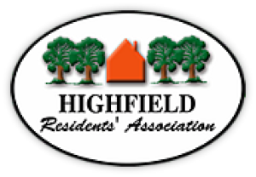

Objection to Premises Licence Application 2021/039100/SPRN
Highfield Residents Association wishes to object to the granting of a premises licence in the above application.
The area covered by the Association abuts the Common, some of its members live very close to the Common, and many of them enjoy recreation and exercise there. The Old Cemetery is especially appreciated as a place of quiet contemplation and reflection as well as an important link to the City’s history and heritage, and a key part of the city as a City of Culture.
There are many, many venues in the city that have a licence to sell alcohol and to play music. The Old Cemetery is a small haven in a busy city and has a quite different role and purpose.
HRA cannot think of a development that would be less suitable or more inappropriate than what is proposed here for almost all-hours sale/consumption of liquor and music. It would completely change the character of this much-loved asset as well as creating detriment and loss of amenity to a wide range of citizens. It is also disrespectful to those who are buried there and to their relations and loved ones. HRA therefore trusts that the Council as licensing authority will not agree to this application.

Barbara Claridge

Mrs Barbara Claridge - Secretary, HRA

HRA.HonSec@gmail.com
https://www.highfieldresidents.org.uk/join-renew/

