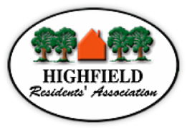
Agenda HRA Committee Meeting Tuesday 8 March 2022
Highfield Church Hall Lounge Room 19:00h

Prof. Roger Brown will Chair the meeting

- Prof. Roger Brown - Welcome and opening remarks
- Apologies
- Declarations of interest
- Approval of the Minutes from the Committee Meeting 8 February 2022
- Matters Arising not covered elsewhere:
  - Planning panel meeting RB /JG. Leigh Road approved. Lovers Walk approved and next stage planning approval for Common land underway
  - Local Plan
  - 20mph in Highfield
  - 30mph The Avenue
  - HMO
  - 34 Crofton Close
- Information from Councillors
  - Portswood Transport hub survey
https://www.highfieldresidents.org.uk/southampton-city-council-has-launched-a-survey-about-a-transport-hub-in-portswood-deadline-20-march-2022/

- University Liaison (JW / KF)

- Endorsement of the Southampton National Park City Project (plus charter)
- Planning
- 1 Blenheim Gardens (HMO)
- Planning Appeal Upper Shaftesbury

- Reports
- Finance (MB) – income/expenditure for the last period
- Membership (NM)

- Police liaison – Crime information sharing WhatsApp group (for Highfield) (NJ)
Website / Facebook (NJ)
- A.O.B.
  - The Friends of Southampton’s Museums, Archives and Galleries

