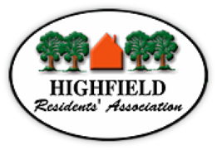
Agenda HRA Committee Meeting Tuesday 10 May 2022
Highfield Church Hall 19:00h

Prof. Roger Brown will Chair the meeting

- Welcome and opening remarks - Prof. Roger Brown
- Apologies
- Declarations of interest
- Approval of the Minutes from the Committee Meeting 12 April 2022
- Matters Arising not covered elsewhere:
  - HMO progress (NSCF)
  - Civic University Agreement (RB)
  - Police numbers (RB)
- Information from Councillors
- University Liaison
- Planning
  - 34 Crofton Close update (NJ)
  - 17B Brookvale Road (update - conditional permission granted for garden shed)
  - 39 Tennyson Road - Planning Inspectorate Decision
  - 12 Russell Place (update on court case)
  - 11 Russell Place – Planning Application
  - Highfield House Hotel
- Reports
  - Finance (MB) – income/expenditure for the last period. Presentation of HRA 2021 Accounts for Examiner (see attached document)
  - Membership (NM)
- Website / Facebook (NJ) Digital Communications
- Facebook page
Website
E-news
- HRA Crime information sharing WhatsApp group for Highfield
- A.O.B.
  - Wheelie bins on Highfield Lane (HRA member request)
  - HRA Social

