Highways Service Partnership
City Depot and Recycling Park
First Avenue, Millbrook
Southampton
SO15 0LJ

IMPORTANT ROADWORKS INFO ENCLOSED 01 August 2022

The Occupier
Southampton
Post Code
Dear Occupier

Thomas Lewis Way Junction with St Denys Road (A3035) Pedestrian and Cycleway Improvements
Balfour Beatty is working in partnership with Southampton City Council to manage the highways service across Southampton. As part of this, we are improving access for pedestrians and cyclists at the junction of Thomas Lewis Way and St Denys Road (please see map overleaf).
The junction improvements will include:
- A new cycleway along St Denys Road crossing the junction and safer crossing points for pedestrians
- New intelligent traffic signals at the junction. These will provide smoother and more efficient traffic movements in the area
- An extension to the dedicated left turning lane on Thomas Lewis Way onto St Denys Road heading towards Bitterne Triangle to reduce congestion.
Work is planned to start on Sunday 21 August for approximately 15 weeks and will be completed in phases, that will require lane restrictions and some overnight closures.
Phase 1
The traffic management will be put out on the evening of Sunday 21 August for our works to start on Monday 22 August. To create a safe working area for our team we will be removing all eastbound access from Portswood onto the junction, however all westbound traffic from Thomas Lewis Way and St Denys will be able to pass through.
We will also be removing the dedicated left hand turning lane from St Denys onto Thomas Lewis Way. Traffic, excluding HGVs, will be able to turn left (southbound) using the other lanes. Due to the tight turning circle here HGV’s will need to follow the signed diversion route.
Our work will require us to upgrade the ducting that runs under the road surface, therefore to minimise disruption to traffic we will be working overnight during the first week, from Monday 22 August for 5 nights, to undertake this element of the work.
These works will start on the northbound carriageway heading towards Swaythling. Once this is complete, the team will work on the eastbound carriageway towards St Denys and finally the westbound carriageway coming from St Denys. Access for pedestrians and cyclists crossing the junction will be maintained. We strongly advise you to check https://myjourneysouthampton.com for up-to-date information on these works if you need to use this junction during this time.
Phase 2 and 3
During this second phase we will be working on the western approach from Portswood, this area will continue to be one way throughout this phase. Please note that there will be a change of traffic management in the area to place vehicles on the opposite carriageway, however the access restrictions will remain the same throughout. Pedestrian access will be maintained.
Once completed we will then progress to the third phase which will see our teams working more in the pedestrian areas of the junction, on the eastern side of St Denys Road near to Osborne Road North. These will include the addition of tactile paving to assist with pedestrians crossing the road. At the same time we will install a crossing point on the island opposite on the western arm of the road.
Once these phases of work are complete, the final part of these works will include resurfacing and relining the road to make it ready for reopening. These will be done overnight and additional information will be sent to residents likely to be affected by these works nearer the time.
Phase 4 – Future planned works
A final phase is planned to extend the dedicated left hand turning lane from Thomas Lewis Way (southbound) into St Denys this will further reduce congestion for people travelling southbound. These works will start after the main junction improvements and impacted residents will informed of the dates and any traffic restrictions closer to the time.
We appreciate that these works will cause disruption in the area, and we would like to take this opportunity to apologise in advance for any inconvenience or disruption this may cause, and thank you for your support whilst we deliver these improvements.
For information on roadworks and journey planning, visit https://myjourneysouthampton.com, and for up to the minute travel information in the city and updates on this scheme, follow us on Twitter @SCChighways. For any other enquiries, please email roadworks@southampton.gov.uk.
Map showing traffic flow during Phases 1-3 of our works

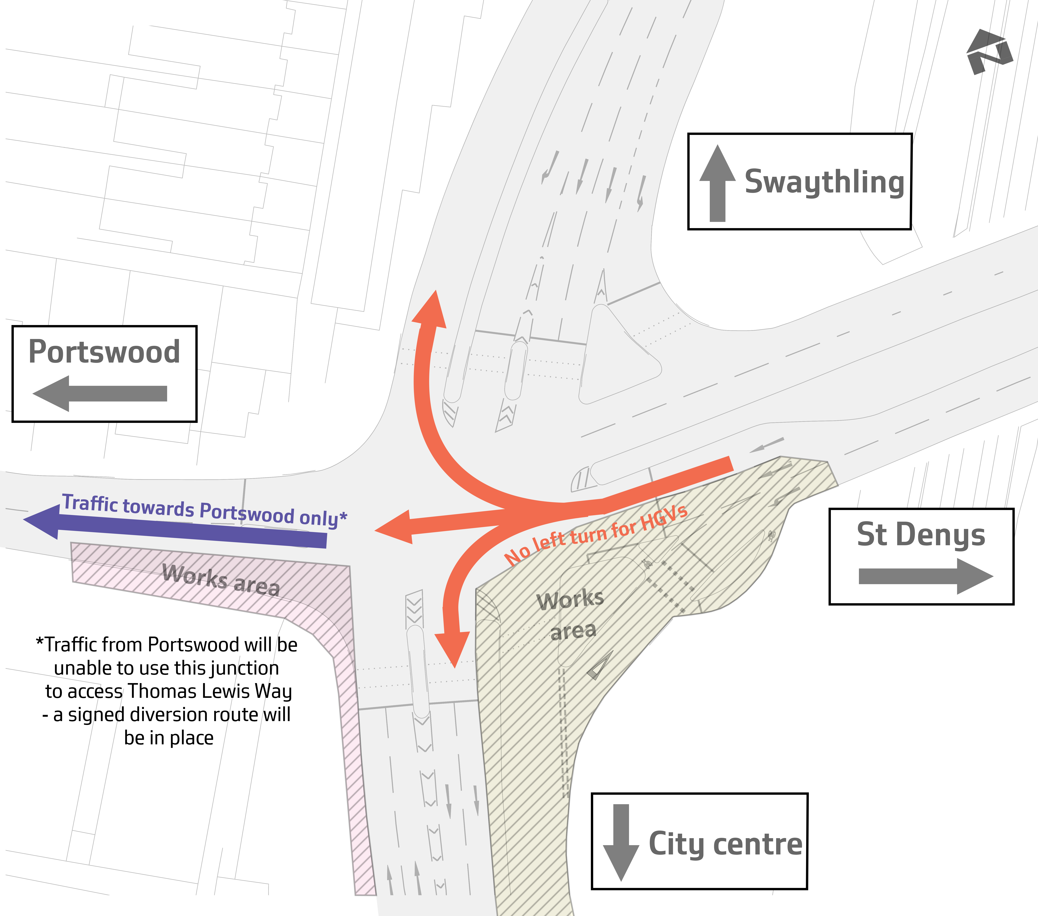
Yours faithfully,
Laura Amos
Communications Manager | Southampton Highways Partnership

