**Toy Appeal gift ideas**

The Southampton Toy Appeal was first set up in 1988 and from humble beginnings it has grown to become a festive tradition in the city.

We ask for new toys and gifts to be donated for vulnerable children and young people from birth through to eighteen years of age who are supported by Southampton’s Children’s Services. We also support a number of families experiencing severe financial difficulties.

On behalf of the children and young people that receive the new toys and gifts, we are grateful for every donation. However, we have found that there is an increased need for gifts for young people, especially males aged 12-18.

If you would like to help, here is a list of gift ideas you may find useful:

* Man bags, rucksacks, and wallets
* Handbags and purses
* Mobile phone accessories
* Touch screen gloves
* Skateboard and accessories (for example, helmets, knee and elbow protectors)
* Clothing: Nike and Vans t-shirts, hats and gloves, baseball caps, Nike and Superdry hoodies
* Headphones (noise cancelling)
* Earbuds (wired and wireless)
* Hair dryers
* Lava lamps
* Fairy lights
* Sports equipment (for example, footballs, basketballs, goalie gloves, goals, boxing gloves)
* Wireless speakers
* Makeup
* Toiletries (for example face care, body wash/spray)
* Electric/battery operated beard trimmers/shavers
* Scooters
* Vouchers for: JD Sports, Sports Direct, New Look, and H&M

|  |
| --- |
| **2024 Southampton Toy Appeal** |



[This Photo](https://freepngimg.com/png/94-snowflake-png-image) by Unknown Author is licensed under [CC BY-NC](https://creativecommons.org/licenses/by-nc/3.0/)



[This Photo](https://freepngimg.com/png/94-snowflake-png-image) by Unknown Author is licensed under [CC BY-NC](https://creativecommons.org/licenses/by-nc/3.0/)

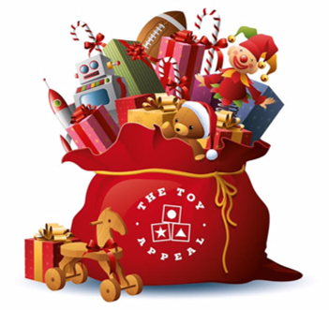



[This Photo](https://freepngimg.com/png/94-snowflake-png-image) by Unknown Author is licensed under [CC BY-NC](https://creativecommons.org/licenses/by-nc/3.0/)



[This Photo](https://freepngimg.com/png/94-snowflake-png-image) by Unknown Author is licensed under [CC BY-NC](https://creativecommons.org/licenses/by-nc/3.0/)



[This Photo](https://freepngimg.com/png/94-snowflake-png-image) by Unknown Author is licensed under [CC BY-NC](https://creativecommons.org/licenses/by-nc/3.0/)



[This Photo](https://freepngimg.com/png/94-snowflake-png-image) by Unknown Author is licensed under [CC BY-NC](https://creativecommons.org/licenses/by-nc/3.0/)

**We need new and unwrapped**

**toys and gifts**

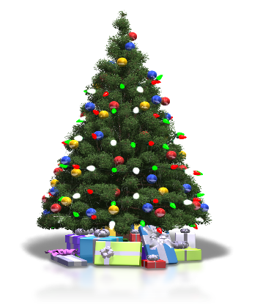

[This Photo](https://freepngimg.com/png/30416-christmas-tree-transparent-background) by Unknown Author is licensed under [CC BY-NC](https://creativecommons.org/licenses/by-nc/3.0/)



[This Photo](https://freepngimg.com/png/30416-christmas-tree-transparent-background) by Unknown Author is licensed under [CC BY-NC](https://creativecommons.org/licenses/by-nc/3.0/)

**for ages 0-18 years.**