Welcome to the 180th anniversary of the Opening of the (old) Southampton Cemetery, an event FoSOC are celebrating on the
10th May 2026

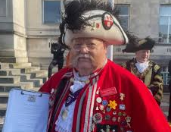
Town Crier – Alan Spencer
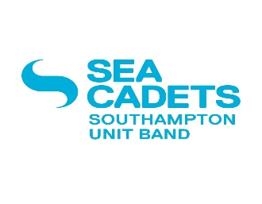
Will announce the start with - Sea Cadets at 10.00am followed by a prayer by The Bishop of Winchester and an address by the Lord Mayor of Southampton then Sea Cadets from 10.15am for 30 minutes

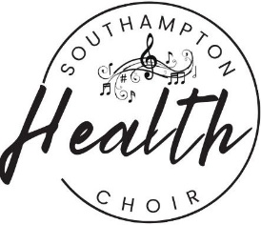
The Choir - 11.00am – 11.45am inside the Anglican Chapel

Talk - Inside Non-Conformist Chapel
12(noon) – 1pm Bookings only

The Shantywomen 1.00pm - 1.45 outside/large gazebo.
Walk - Structure /History– 1.50 - 2.50
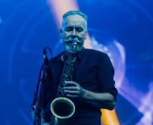
Walk – Trees/Shrubs flowers 3 - 4pm

Mike Blatchford & the Haze Band 4-5pm outside large gazebo.
King Edwards VI School- Artwork & book will be on show.
Refreshment from 1.00pm – 5 pm inside the Non-Conformist Chapel - no charges but donation gratefully received. Three acts outside but if raining will be inside either Chapels - Thank you!

